FIT3179 Data Visualization Week 9 Homework

Studio: 26

Tutor: Ashwini

Name: Xiange Wang

Student ID: 31185835

**Web link**: <https://xiange-wang.github.io/3179/>

**Screenshot**

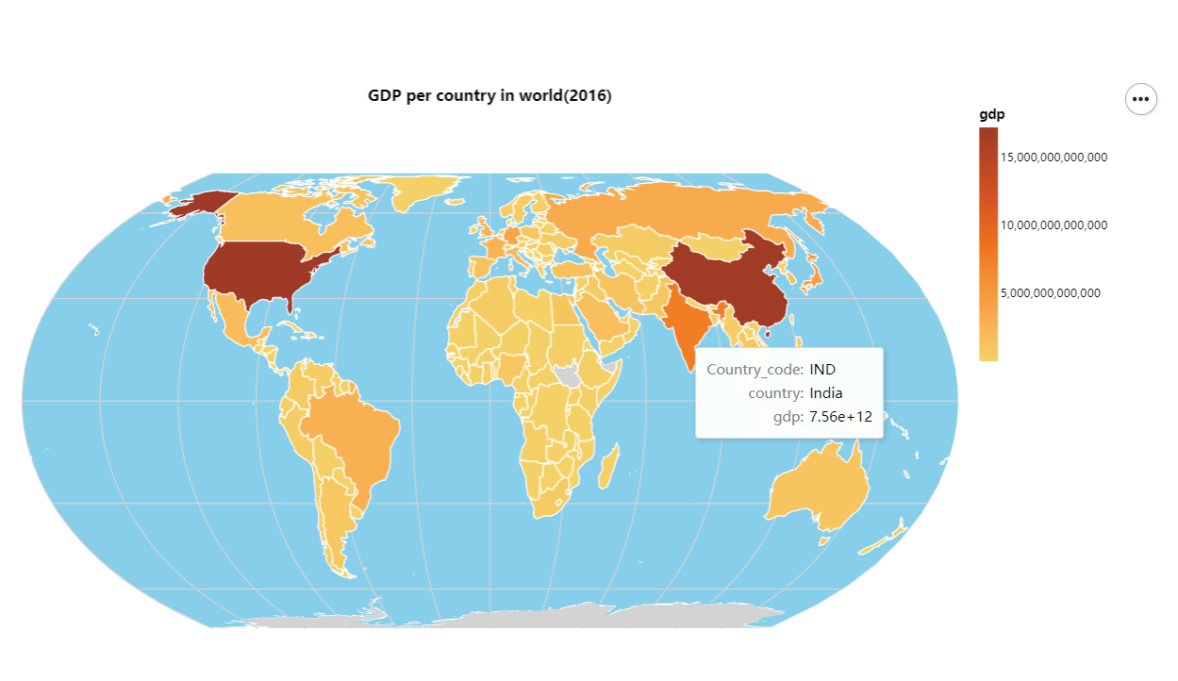

**Domain:**

GDP of different countries in 2016. The selected countries are those with detailed energy consumption information in the dataset. The purpose is to help analyze the correlation between GDP and energy consumption.

**Source**: <https://www.kaggle.com/datasets/pralabhpoudel/world-energy-consumption>

**Author:** PRALABH POUDEL

**Data Type:** table

**Data attribute**: ISO_code(categorical), Country(categorical), GDP (quantitative)

**Transformation:**

The main purpose of this visualization is to show readers the GDP of various countries and help them analyze the relationship between energy consumption and GDP in conjunction with other visualizations. Therefore, most other attributes are ignored. The country and ISO_code are used to assist in plotting and indicating the respective countries. The Year is for filtering data of a specific year for easier comparison. The dataset is very large, so deleting some missing data will not have an impact, so I directly removed many null values.

**Justification:**

The Choropleth Map was chosen for its ability to visualize the relative differences in GDP between countries. By using different colors or shading, readers can quickly identify which countries have higher or lower GDP. The Proportional Symbol Map, on the other hand, may result in overlapping symbols, especially in countries that are geographically close to each other.The Dot Map, on the other hand, is unsuitable for representing aggregate values, as it is more often used to show the distribution of events or phenomena. Therefore, Choropleth Map is the best choice to show GDP between countries.